*Smart Security: Biometrics and Cloud Computing*

Drake Austin Csage Benjamin Strandskov  
EGR 597: Internet of Things EGR 597: Internet of Things  
Central Michigan University Central Michigan UniversityMt. Pleasant, Michigan Mt. Pleasant, Michigan  
[Csage1da@cmich.edu](mailto:Csage1da@cmich.edu) [stran1b@cmich.edu](mailto:stran1b@cmich.edu)

**Abstract** - IoT is an electrical and computer engineering field that is growing rapidly. Unfortunately, the automotive industry is always a step behind when it comes to security. With the ability to rent out your car, smart toll systems on the rise, and more people utilizing the digital wallets, the smart security system opens up a very broad range of what this can optimize and make easier for the automotive customer, all while securing the customer’s vehicle(s). The idea behind the smart security system is to use facial recognition not only to secure the vehicle, but to preload the user settings as well. The smart security system offers a valid form of security to the car, the availability to offer safer driving techniques, and preload the user’s settings of the vehicle.

1. **Introduction**

With the growing field of IoT, security is a topic that is often overlooked. Simple to more complex topics include hackers’ ability to signal crack a key fob using an RF attack, to controlling a network and shutting down a manufacturing plant. Simpler enough, another topic that is often overlooked in security is simply unlocking a car. Security professionals try their best to keep the networks secure, but often are mislead by the more simple topics: unlocking and stealing items inside a car.

Biometric facial recognition is a topic that can increase the security of a car. With the internet of things, we can utilize unlocking a car with biometrics. The camera connected to the Raspberry Pi 3 will image process the person trying to unlock the car by sending the information over the the PostGreSQL database. The database will compute the information and give a yes or no to unlocking the car. If “Yes,” the car will unlock and optimize the person’s car settings. These settings will include but are not limited to: seat position, Apple Music or Spotify accounts, mirror position(s), the Apple Wallet, unlocking or locking the glove box, and utilizing phone as a key (upcoming application used in the automotive industry). Connecting the music accounts will allow the driver to have music playlists available, the digital wallets enable easier access to smart toll systems, and phone as a key makes it easier to transfer rights to a person and enable them to drive a vehicle for a period of time. If “No,” the camera will take a screenshot of whomever is attempting to unlock the vehicle and send a screenshot to the owner of the vehicle.

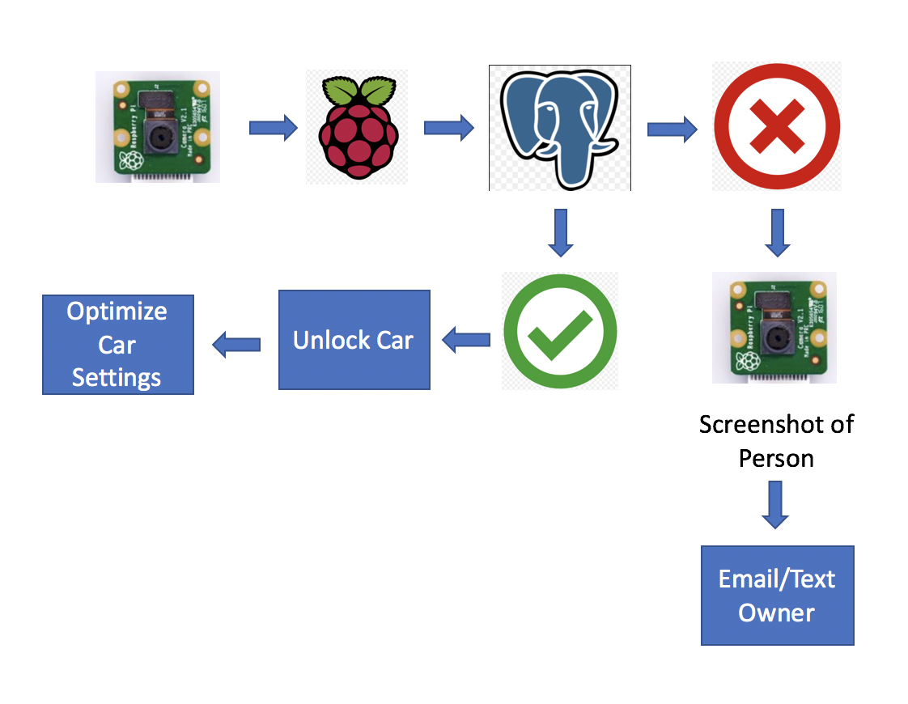

**Figure 1: Block Diagram of the Smart Security System**

# II. **Literature Review**

## There exists a significant body of works that focuses on the use of biometrics as a form of user authentication and data security.

A similar concept was explored in [1], in which facial recognition was used to unlock a personal assistant platform customized to the person who unlocked it. This system increased the processing capabilities of the system and response time by outsourcing the computations to web servers over using the onboard microcontroller processor.

The authors of [2] used the biometric of fingerprint scanning as their form of user authentication. This concept used PostgreSQL as the database management system, and PHP language for web platform coding.

The work done in [3] was to create a facial recognition system using Haar feature-based cascade classifier. This system boasted high accuracy and fast computational time in comparing biometric samples.

##### **References**

1. R. Novosel, B. Meden, Z. Emersic, V. Struc, P. Peer. “Face recognition with Raspberry Pi for IoT Environments,” International Electrotechnical and Computer Science Conference, 2017.
2. L. Arunkumar, A. Arun Raja. “Biometrics Authentication Using Raspberry Pi.” *International Journal for Trends in Engineering & Technology*, vol. 5.2, 2015.
3. O. Nikisins, R. Fuksis, A. Kadikis, M. Greitans. “Face recognition system on Raspberry Pi,” International Conference on Information Processing and Control Engineering, 2015.